
Approach to Market
To establish Contract for Independent Evaluation - She Leads Women's Leadership Project in Nepal
Reference ID: KM23/62#4
UNSPSC: 80101606 Project Monitoring and Evaluation
This Approach to Market (ATM) is to undertake an independent evaluation of She Leads Women’s Leadership Project in Nepal.

The evaluation will assess:
- the extent to which the project has achieved its intended outcomes and impacts;
- the appropriateness and relevance of the project in addressing the identified needs and priorities of the target beneficiaries;
- the efficiency and cost-effectiveness of the program and partnership arrangement in achieving the outcomes ;
- the sustainability of project results and identify factors that may influence the sustainability of outcomes beyond the project duration; and
- the contribution of project in advancing gender equality, disability inclusion, and social inclusion.

Department of Foreign Affairs and Trade (the Customer) is seeking submissions for the provision of the consultancy services (the Requirement) as described in this ATM comprising:
- this CCS ATM, including the Statement of Requirement
- the CCS ATM Response Form
- the CCS ATM Annexes (if any)
- the Commonwealth ATM Terms
- the Additional Contract Terms (if any)
- the Commonwealth Contract Terms
- the Commonwealth Contracting Suite Glossary and Interpretation.
In submitting a response, Potential Suppliers are required to comply with all requirements set out in the Commonwealth Approach to Market Terms (a copy of which is included in this document), and if successful, agree to enter into a contract which incorporates the Commonwealth Contract Terms available at https://www.finance.gov.au/government/procurement/commonwealth-contracting-suite-ccs#ccs-terms.
Statement of Requirement
A.A.1 Key Information and Dates
Approach to Market
Event | Details
ATM Closing Date | Friday, 15 September 2023
ATM Closing Time | 5:00 pm
Industry Briefing | Unless otherwise notified by an addendum, there are no industry briefing sessions for this ATM.
Site Inspection | Unless otherwise notified by an addendum, there are no site inspections for this ATM.
Minimum Content and Format Requirements | For a Potential Supplier’s Response to be eligible for consideration the Potential Supplier’s Response must comply with the matters addressed in A.B.4.2 of the Commonwealth ATM Terms.
Conditions for Participation | No conditions for participation are specified.
Proposed Contract
Event | Details
Proposed Start Date: | Monday, 25 September 2023
Proposed End Date: | The Contract will terminate on Tuesday, 31 October 2023.
Contract Extension Option | The Contract will include the following extension option(s): one month.

A.A.2 The Requirement

Background
After the promulgation of Nepal’s 2015 Constitution, the 2017 local elections, the first local elections in two decades, resulted in the election of over 35,000 local officials in 2017. Women made up approximately 41 percent (14,345 women nationwide) of those elected to local governments – the majority of whom were serving in official elected or government roles for the first time. Women elected in local governments face challenges of undertaking roles that have yet to be clearly defined while navigated spaces typically dominated by men. To support elected women in local government, the International Foundation for Electoral Systems (IFES), with the generous support of the Australian Department of Foreign Affairs and Trade (DFAT) and the Swiss Agency for Development and Cooperation (SDC), initiated the She Leads women’s leadership program to build the skills, knowledge and networks to succeed in their roles in January 2019. The program began with a baseline assessment, a pilot training and curriculum development, however, implementation of the training activities was delayed due to a prolonged government approval process, with approval ultimately received from the Social Welfare Council in June 2020. Additionally, the COVID-19 pandemic delayed the start of trainings for elected women due to government restrictions on gatherings and lockdown orders in some areas.
She Leads is IFES’ flagship women’s leadership program in the Asia-Pacific region, training women leaders on the necessary skills and knowledge to take on leadership roles in democratic processes. In Nepal, the She Leads program is implemented with a locally tailored, participatory, and activity-based approach, to build capacity of elected women leaders in local governments in Koshi Province and Madhes Province. Civil society organization (CSO) Center for Dalit Women in Nepal (CDWN) in Koshi Province has been implementing the project since 2019. In 2021, DFAT provided a cost increase to the project to expand She Leads to Madhes Province, and CSO Mandwi is implementing the She Leads project in Madhes Province. The program is scheduled to conclude in December 2023.
Elected women in local government are the primary beneficiaries across 67 municipalities in 10 districts, namely Jhapa, Morang, Sunsari, Khotang, Okhaldhunga in Koshi Province and Bara, Rautahat, Sarlahi, Mahottari, and Dhanusa in Madhes Province. Secondary beneficiaries include family members of elected women in the She Leads program, community male leaders and allies, elected male leaders, political party leaders, journalists, and community members in She Leads project areas. The project ensures that these stakeholders provide positive support to EWRs, enabling them to effectively fulfill their responsibilities.
To date, the project has trained 2,188 elected women through a progressive, modular training program. Each She Leads participant completes multiple modules of training over the course of the program and completes post-training assignments to operationalize the skills from the training sessions. A full list of topics covered in the trainings will be provided to the evaluation team by IFES as part of the desk review.
The primary audience for this evaluation report will be the She Leads donors, DFAT and SDC. The evaluation report will also be shared with IFES, and IFES will communicate key recommendations and findings with CDWN and Mandwi.

Purpose of the Evaluation
The evaluation will collect data from both primary and secondary sources to track and document progress toward the goal and outcomes expected from the program.
The evaluation will assess:
- the extent to which the project has achieved its intended outcomes and impacts;
- the appropriateness and relevance of the project in addressing the identified needs and priorities of the target beneficiaries;
- the efficiency and cost-effectiveness of the program and partnership arrangement in achieving the outcomes ;
- the sustainability of project results and identify factors that may influence the sustainability of outcomes beyond the project duration; and
- the contribution of project in advancing gender equality, disability inclusion, and social inclusion.

Methodology
The evaluation should incorporate a comprehensive approach by utilizing both quantitative and qualitative methods for data collection and analysis. The suggested methodologies include:
- Desk Review: Review project documentation, such as project log frame, monitoring and evaluation data, semi-annual reports, program assessments, and relevant background materials.
- Key Informant Interviews: Conducting key informant interviews with various project stakeholders, including elected women in the She Leads program, family members of She Leads participants, elected men, journalists, political party representatives, secondary beneficiary groups which includes a representative sample of groups including general citizens that have benefitted from strengthened women’s representation, IFES staff and CSO partner staff.
- Field Research: Undertake field visits to project sites to observe project activities and gather qualitative data through interviews, focus group discussions, and direct observations.
- Analysis: Analyze the collected data and information to draw meaningful conclusions and develop evidence-based recommendations.

Key Evaluation Questions
The evaluation will address the following over-arching questions .More detailed questions will be developed during evaluation plan that relate to these over-arching questions for each of the data collection tools. All research instruments, including detailed questions, used for this assessment will be developed by evaluation team in coordination with DFAT and IFES.
The over-arching questions are as follows:

1) Effectiveness - Did the investment achieve the outcomes that were expected over the lifetime of this investment ?
- Is there strong evidence of high level of satisfaction and behavior change among partners and beneficiaries?
- Has the investment delivered additional outcomes to respond to a changed operating context, is there strong evidence that these outcomes were positive and contributed to the achievement of the overall objective, or end-of-investment outcomes of the investment?
- How was policy dialogue or partnerships used to effectively influence the development agenda and support the achievement of the end of investment outcomes ?
- Was the investment flexible in adapting to changes in the development context or partner priorities ?
- To what degree have improvements been made in the electoral laws, policies, guidelines, and procedures through the Project’s inputs?
- Was the implementation time adequate given the context?
- What are the main factors, including political ones, affecting the achievement or non-achievement of the Project’s outcomes, and what could the various partners be doing to overcome those factors?

2) Efficiency - Did the investment make an appropriate and efficient use of partners’ time and resources to achieve the end-of-investment outcomes?
- To what extent were the partner and modalities appropriate (i.e. did we select the right partner, should we be focusing more on grassroots organizations, was it the appropriate approach?)
- Were the governance arrangements good and efficient and supported the effective implementation of the investment?
- Did the implementing agency and downstream partners have appropriate staff, skills and experience to achieve the intended end-of-program outcomes ?
- To what extent did the program appropriately complement/align with Australia’s development priorities in the Nepal country program (i.e. does it align with the COVID-19 Development Response Plan , did it complement DFAT’s Gender Equality and Women’s Empowerment Strategy, does it align with the other donor funded initiatives)?
- How has the partner been able to create synergies with other DFAT and/or SDC interventions?

3) Gender Equality - Did the investment make a difference to gender equality and social inclusion in Nepal?
- Did a robust gender analysis inform appropriate strategies for gender equality and social inclusion and were those strategies implemented effectively?
- Was optimal budget available to achieve gender equality results and staff/ partners had full access to gender expertise?
- Did the M&E system collect comprehensive sex-disaggregated data, which was analysed and used to drive improvement and learning?
- Did the investment support local partners and beneficiary organisations to increasingly prioritise gender equality and take action on gender equality in their own policies and practices?

4) Disability - Did the investment actively involve people with disabilities and/or disabled people’s organizations (DPO) in planning, implementation and monitoring and evaluation ?
- Were people with disabilities and/or DPOs engaged in program design, implementation, monitoring and evaluation with strong commitment to allocating resources to facilitate their engagement?

5) Disability - Did the investment identify and address barriers to inclusion, provide opportunities for participation, and enable people with disabilities to benefit equally from the aid investment?
- Were evidence-based disability-inclusive measures in the design and throughout implementation, informed by quality analysis of barriers to inclusion in relevant contexts/sectors.
- Did the investment budget for disability-inclusive measures, including for reasonable accommodation and accessibility measures, and all requirements of people with disabilities were met?
- How have the various project partners defined "meaningful women's representation" and how have beneficiaries understood it? Have underlying contexts and barriers, which may differ from community to community been identified/addressed?

6) Relevance - Was this the right thing to do ?
- To what degree did the project’s objectives and design respond to the main challenges in the local environment for women elected representatives in Nepal?

7) Sustainability - Will the benefits of the investment last ?
- Was a good-quality sustainability strategy developed and implemented over the lifetime of the investment ?
- Did the investment make good use of local systems and the evidence demonstrates that the investment strengthened the capacity of local institutions in almost all end of investment outcome areas ?
- Is there evidence that demonstrates a high level of ownership of the investment by partners and beneficiaries ?
- To what extent are the objectives and outcomes of the program still valid following the second cycle of elections?
- What is the likelihood that the progress achieved with support from the Project will continue after the Project comes to a closure?
- What are the risks that may hinder or obstruct continued progress, and how are they being mitigated?
- What has been the degree of stakeholder (including beneficiary) and partner involvement in the various processes related to the outcome and the establishment of local ownership?
- How can the project be best aligned with the country’s priorities and be harmonized with interventions of other donors?
- How can the project support and engage with the ECN?
- What can be discontinued? Are there additional areas in need of future support?

Timeline

Indicative dates | Activity | Indicative days allocated
26 Sept 2023 | Initial document review and introductory brief with team at Post | 1
27 – 28 Sept 2023 | Comprehensive document review | 2
29 Sept 2023 | Draft and Finalize evaluation plan based on DFAT's feedback | 1
2-4 Oct 2023 | Interviews and discussions in Kathmandu | 2
5- 13 Oct 2023 | Field visits | 9
18 Oct 2023 | Prepare and Present initial findings to DFAT and SDC | 1
19 -30 Oct 2023 | Data analysis and reporting writing  Note: October 21- 25th Dashain holiday | 5
31 Oct 2023 | Draft report to DFAT | 0
3 Nov 2023 | Finalise report based on DFAT’s feedback | 1
6 Nov 2023 | Final report due to DFAT | 0
 | Total Days | 22

Reporting and Communication
Regular progress reports should be submitted to DFAT. The evaluator(s) should maintain open communication channels with the project stakeholders throughout the evaluation process. The final evaluation report should be submitted in both electronic and hard copy formats.

Ethical Considerations
The evaluator(s) should adhere to ethical principles, ensuring confidentiality, informed consent, and the protection of human subjects throughout the evaluation process. Any potential conflicts of interest should be disclosed and managed appropriately.

Qualifications and Experience
Evaluation Team Leader (22 days)
- Master's or advanced degree in relevant fields such as social sciences, gender, public administration
- Extensive experience in designing and leading evaluations, particularly on gender equality, disability and social inclusion.
- Deep understanding of qualitative and quantitative evaluation methodologies.
- Background in women's leadership issues, gender dynamics, and related theories.
- Excellent written and oral communication abilities for comprehensive evaluation reports and presentations.
- Sensitivity to ethical considerations and experience working with vulnerable or marginalized groups.
- Ability to work collaboratively with program stakeholders, participants, and funders.
- Proficiency in both quantitative (surveys, assessments) and qualitative (interviews, focus groups) data collection techniques.
- Cultural sensitivity and understanding of gender-related nuances in evaluation.
Research Assistant: (15 days)
- Bachelor's or preferably master's degree in a relevant field like social sciences, economics, or public policy.
- Strong foundation in research methods, both qualitative and quantitative, with experience in research design, data collection, and analysis.
- Excellent written and verbal communication skills for preparing clear reports, summaries, and presentations.
- Sound understanding of research ethics and ethical data handling practices.

Responsibilities of Researchers

The team leader (independent researcher) and supporting researcher have specific responsibilities during the evaluation process:

Evaluation Team Leader:
- Initial document review to inform the evaluation plan.
- Conduct data collection including stakeholder interviews.
- Feedback to relevant information users (key stakeholders, beneficiaries, other donors, partner government) to share and gain insight into initial findings and recommendations.
- Process and interpret data collected.
- Prepare the draft evaluation report.
- Brief DFAT on the findings, respond to comments and complete final evaluation report and products as agreed upon in the evaluation plan.

Research Assistant:
- Assist the team leader in developing the evaluation framework and methodology.
- Conduct literature reviews and contribute to the review of project documentation.
- Participate in key informant interviews and assist with data collection.
- Analyze quantitative and qualitative data collected during the evaluation.
- Support the team leader in data synthesis and drawing conclusions.
- Provide input and feedback on the evaluation report.
- Assist with the presentation of findings and recommendations.

A.A.2(a) Standards
Potential Suppliers must ensure that any goods and services proposed are capable of complying with all applicable Australian standards and any Australian and international standards specified in this Statement of Requirement. Potential Suppliers should note that they may be required to enable the Customer, or an independent assessor, to conduct periodic audits to confirm compliance with those standards.
Web Content Accessibility
The Supplier must ensure that any website, associated material and/or online publications (where applicable) complies with the Web Content Accessibility Guidelines available at:
https://www.dfat.gov.au/about-us/about-this-website/accessible-documents/creating-documents-meet-accessibility-guidelines
DFAT Evaluation Standards
The Evaluation Plan should adhere to the following DFAT standards (Refer Annex 1 – Standard 9: Independent Evaluation Plan)
- The plan is based on a collaborative approach, and it should be evaluated is described and the purpose and primary intended users of the evaluation are clearly identified.
- A summary is provided to orient the reader to the overall evaluation design and methodology.
- Limitations or constraints on the evaluation are described (for example time frame, resources, available data, political sensitivities).
- The key evaluation questions are supplemented by detailed descriptions and/or sub-questions.
- It is clear which questions are considered to be of higher priority and are expected to provide the most important information.
- There is sufficient flexibility to be able to address important unexpected issues as they emerge.
- The methods to collect quantitative and qualitative data, including stakeholders to be interviewed are described for each question (or related questions).
- The proposed data collection methods are appropriate for the questions posed.
- Triangulation of data collection methods is proposed to strengthen the confidence in the findings.
- The sampling strategy is clear and appropriate for the evaluation questions posed.
- The Plan describes how data will be processed and analyzed.
- The Plan identifies ethical issues and how they will be addressed.
- The process for making judgments is clear, including the strength of evidence for making these judgements.
- Approaches to enhance the use of findings are outlined (if requested in the terms of reference).
- The Plan provides an indicative schedule which DFAT uses to create the final schedule.
- Roles and responsibilities of team members, DFAT and any reference group are clear.
- The Plan describes how the evaluation will be quality assured.
- The Plan for publication of the final Report is documented.
The Evaluation Report will be prepared in according with the requirements outlined under Annex 2 – Standard 10: Independent Evaluation Reports
A.A.2(b) Security Requirements
None Specified
A.A.2(c) Work Health and Safety
Prior to commencement of the Contract, the Customer and the Supplier’s Contract Manager will identify any potential work health and safety (WHS) issues anticipated to arise during the term of the contract and assign management of each issue identified to the party best able to manage it. For all issues assigned to the Supplier, the Supplier will provide the Customer with a WHS plan for approval and no work will commence until the plan is approved unless agreed in writing by the Customer.
Throughout the Contract Term, the Customer and the Supplier will proactively identify and cooperate to manage any WHS issues that arise.
A.A.2(d) Delivery and Acceptance
The Customer must accept or reject any deliverables under the Contract in accordance with the Commonwealth Contract Terms [Clause C.C.11].
Milestone Description | Delivery Location | Due Date
Evaluation Plan | By email | 29 Sept 2023
Presentation of Findings | Australian Embassy, Kathmandu | 18 October 2023
Final Evaluation Report | By email | 6 November 2023
Delivery and Acceptance – Additional Instructions
The evaluation plan and final evaluation report should comply with DFAT’s Evaluation Standards outlined in Annex 1 and 2.
A.A.2(e) Meetings
The Supplier is required to attend meetings as listed in the timeline under Section A.A.2.
A.A.2(f) Facilities and Assistance Offered by the Customer
The Customer will facilitate meetings with relevant stakeholders to undertake the evaluation.
A.A.2(g) Customer Material
She Leads Project design document, Progress Reports, Mid Term Evaluation Report

A.A.3 ATM Distribution
Email Distribution
Updates to this ATM will be distributed via email.
A.A.4 Lodgement of Responses
Email
Responses must be lodged via email to austembassy.kathmandu@dfat.gov.au quoting reference number KM23/62#4 by the Closing Time specified in A.A.1 [Key Information and Dates]. The application should clearly indicate the position i.e. Team Leader or Research Assistant in the subject line of the email.
Response File Format, Naming Convention and Size
The Customer will accept Responses lodged in the following formats:
- Microsoft Word (.docx)
- PDF (.pdf)
The Response file name/s should:
- incorporate the Potential Supplier’s full legal organisation name; and
- reflect the various parts of the bid they represent (where the Response comprises multiple files).
Response files must not exceed a combined file size of 5 megabytes per email.
Responses must be completely self-contained. No embedded files can be included. No hyperlinked or other material may be incorporated by reference.

A.A.5 Customer’s Contact Officers
A.A.5(a) ATM Contact Officer
For all matters relating to this ATM, the Contact Officer is:
Name/Position: Kamakshi Rai Yakthumba, Program Manager, Governance & Global Programs
Email Address: kamakshi.yakthumba@dfat.gov.au
Telephone: 977 1 437 1678
Note: Question Closing Date and Time is set out at item A.A.1 [Key Information and Dates].
A.A.5(b) Complaints Handling
In the first instance, complaints relating to this ATM should be directed to the ATM Contact Officer or:
Name/Position: | Kavitha Kasynathan, Head of Development
Email Address: | kavitha.kasynathan@dfat.gov.au
Telephone: | 977 1 437 1678
If your issue is not resolved refer https://www.finance.gov.au/business/procurement/complaints-handling-charter-complaints for more information relating to the handling of complaints.

Additional Contract Terms
An executed contract will incorporate the Commonwealth Contract Terms and also the following Additional Contract Terms:
A.C.1 Intellectual Property
The Supplier owns the Intellectual Property Rights in the Material created under the Contract.
The Supplier grants to the Customer:
- a non-exclusive, irrevocable, royalty-free, perpetual, world-wide licence to exercise the Intellectual Property Rights in the Material provided under the Contract for any purpose; and
- a right to sub-licence the rights in (a) above to third parties, including to the public under an open access or Creative Commons ‘BY’ licence.
The licence excludes the right of commercial exploitation by the Customer.
The Supplier warrants that it is entitled to grant this licence to the Customer; and that the provision of the Goods and/or Services and any Material by the Supplier under the Contract, and its use by the Customer, in accordance with the Contract, will not infringe any third party’s Intellectual Property Rights and Moral Rights.
Intellectual Property Rights in Goods provided under the Contract or pre-existing Intellectual Property of the Supplier, set out below (if any), will not change as a result of the Contract.
A.C.2 Payment Terms
The Customer must pay the amount of a Correctly Rendered Invoice to the Supplier within thirty (30) calendar days after receiving it, or if this day is not a Business Day, on the next Business Day.
A.C.3 Fraud
A.C.3.1 This clause replaces clause C.C.22.F [Fraud] of the Commonwealth Contract Terms. For the purposes of this clause, ‘Fraud’ means, in delivering the Goods and/or Services under the Contract, dishonestly obtaining a benefit, or causing a loss, by deception or other means, and includes suspected, alleged or attempted fraud.
A.C.3.2 The Supplier must take all reasonable steps to prevent and detect Fraud in relation to the performance of this Contract.
A.C.3.3 Subject to A.C.3.4, if the Supplier becomes aware of any Fraud, it must report the matter to the Customer in writing within five (5) business days.
A.C.3.4 If the Supplier is under a legal obligation not to report a Fraud to the Customer, but local police or other law enforcement agencies provide an exception to permit reporting, the Supplier must report a Fraud to the Customer within five (5) business days of the exception being granted.
A.C.3.5 The Supplier must investigate all Fraud at the Supplier’s expense and in accordance with any reasonable directions or standards required by the Customer. After the investigation is finished, the Supplier must promptly report full details of any Fraud to:
- the Customer (unless the Supplier is under a legal obligation not to report a Fraud to the Customer); and
- the local police and any other appropriate law enforcement agency in the country where the incident occurred, unless the Customer agrees otherwise in writing.
A.C.3.6 If the investigation finds Fraud by the Supplier or its officers, employees or agents, or the Supplier has failed to take reasonable steps to prevent Fraud by a subcontractor, the Supplier must, if directed by the Customer, promptly reimburse or compensate the Customer in full.
A.C.3.7 This clause is a material term of the Contract and survives the termination or expiry of the Contract.
A.C.4 Prohibited dealings
A.C.4.1 The Supplier must ensure that it and its officers, employees, agents and subcontractors involved in delivering Goods and or Services under this Contract are not:
- directly or indirectly engaged in preparing, planning, assisting or fostering a terrorist act;
- listed terrorist organisations for the purposes of the Criminal Code Act 1995 (Cth) (details of listed terrorist organisations are available at:
https://www.nationalsecurity.gov.au/Listedterroristorganisations/Pages/default.aspx);
- subject to sanctions or similar measures under the Charter of the United Nations Act 1945 (Cth) or the Autonomous Sanctions Act 2011 (Cth) (details of individuals and entities are available at:
https://dfat.gov.au/international-relations/security/sanctions/Pages/consolidated-list.aspx;
- listed on the ‘World Bank’s Listing of Ineligible Firms and Individuals’ posted at: http://www.worldbank.org/en/projects-operations/procurement/debarred-firms;
- owned, controlled by, acting on behalf of, or at the direction of persons, or entities referred to in clauses A.C.4.1(a) to A.C.4.1(d) above; or
- providing direct or indirect support, resources or assets (including any grant monies) to persons or entities referred to in clauses A.C.4.1(a) to A.C.4.1(e) above.
A.C.4.2 Where the Supplier becomes aware that there are reasonable grounds to suspect it or any of its officers, employees, agents and subcontractors has or may have contravened any part of clause A.C.4, the Supplier must:
- notify the Customer and confirm that information in writing as soon as possible, which must be no later than within 24 hours;
- immediately take all reasonable action to mitigate the risks; and
- take any other action reasonably required by the Customer.
A.C.4.3 The Supplier must ensure that any subcontract entered into by the Supplier for the purposes of fulfilling its obligations under this Contract imposes on the Subcontractor the same obligations that the Supplier has under this clause A.C.4.
A.C.4.4 This clause is a material term of the Contract and survives the termination or expiry of the Contract.
A.C.5 Anti-corruption
A.C.5.1 The Supplier warrants that the Supplier, its officers, employees, agents and subcontractors have not made or caused to be made, or received or sought to receive, any offer, gift or payment, consideration or benefit of any kind, which would or could be construed as an illegal or corrupt practice, either directly or indirectly to any party, as an inducement or reward in relation to the execution or performance of the Contract.
A.C.5.2 The Supplier must not, and must ensure that its officers, employees, agents and subcontractors, do not:
- make or cause to be made, or receive or seek to receive, any offer, gift or payment, consideration or benefit of any kind, which would or could be construed as an illegal or corrupt practice, either directly or indirectly to any party, as an inducement or reward in relation to the performance of the Contract; and/or
- engage in any practice that could constitute the Australian offence of bribing a foreign public official in relation to the performance of the Contract.
A.C.5.3 If the Supplier becomes aware of any practice, as described in A.C.5.2 (a) or (b), then it must report the matter to the Customer within five (5) business days.
A.C.5.4 This clause is a material term of the Contract and survives the termination or expiry of the Contract.
A.C.6 Child Protection
A.C.6.1 The Supplier must comply, and must ensure that its officers, employees, agents and subcontractors comply with the Department of Foreign Affairs and Trade’s Child Protection Policy, accessible at http://www.dfat.gov.au/childprotection/.
A.C.6.2 The Customer may conduct a review of the Supplier’s compliance with the Child Protection Policy. The Customer will give reasonable notice to the Supplier and the Supplier must participate co-operatively in any such review.
A.C.6.3 If the Customer finds that the Supplier has failed to comply with the Child Protection Policy, the Supplier must promptly, and at the cost of the Supplier, take such actions as are required to ensure compliance with the Child Protection Policy.
A.C.6.4 If an individual, the Supplier must sign and return to the Customer the Child Protection Professional Behaviours at Attachment B to the Child Protection Policy.
A.C.6.5 This clause is a material term of the Contract and survives the termination or expiry of the Contract.
A.C.7 Preventing Sexual Exploitation Abuse and Harassment
A.C.7.1 The Supplier must comply, and must ensure that its officers, employees, agents and subcontractors comply with the Department of Foreign Affairs and Trade’s Preventing Sexual Exploitation Abuse and Harassment Policy, accessible at https://dfat.gov.au/international-relations/themes/preventing-sexual-exploitation-abuse-and-harassment/Pages/default.aspx
A.C.7.2 The Customer may conduct a review of the Supplier’s compliance with the Preventing Sexual Exploitation, Abuse and Harassment Policy. The Customer will give reasonable notice to the Supplier and the Supplier must participate co-operatively in any such review.
A.C.7.3 If the Customer finds that the Supplier has failed to comply with the Preventing Sexual Exploitation, Abuse and Harassment Policy, the Supplier must promptly, and at the cost of the Supplier, take such actions as are required to ensure compliance with the Preventing Sexual Exploitation Abuse and Harassment Policy.
A.C.7.4 This clause is a material term of the Contract and survives the termination or expiry of the Contract.

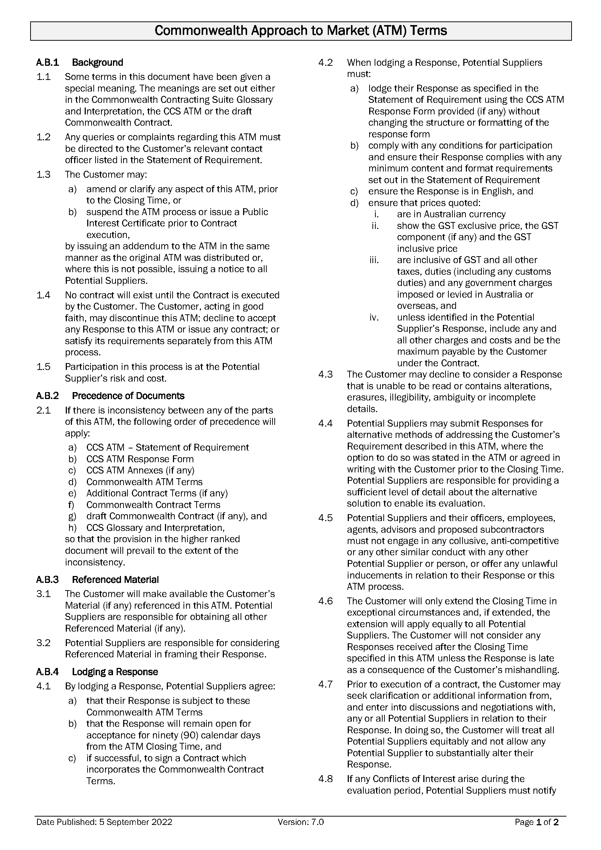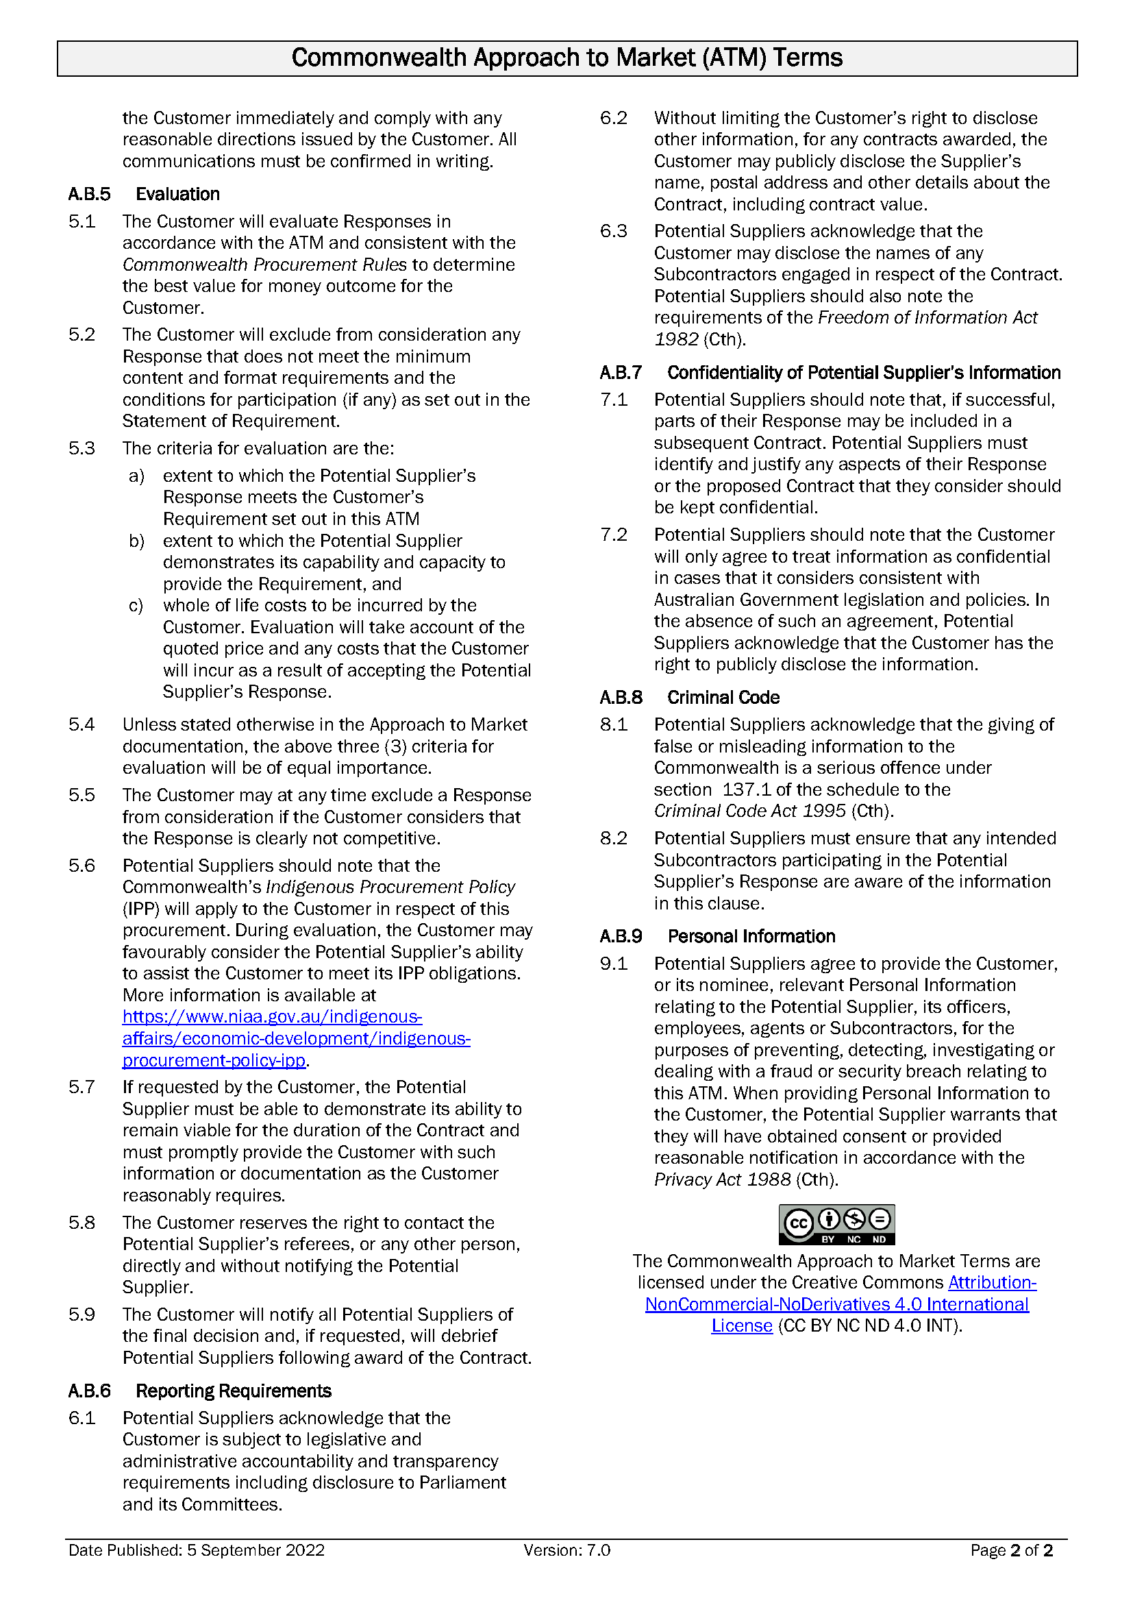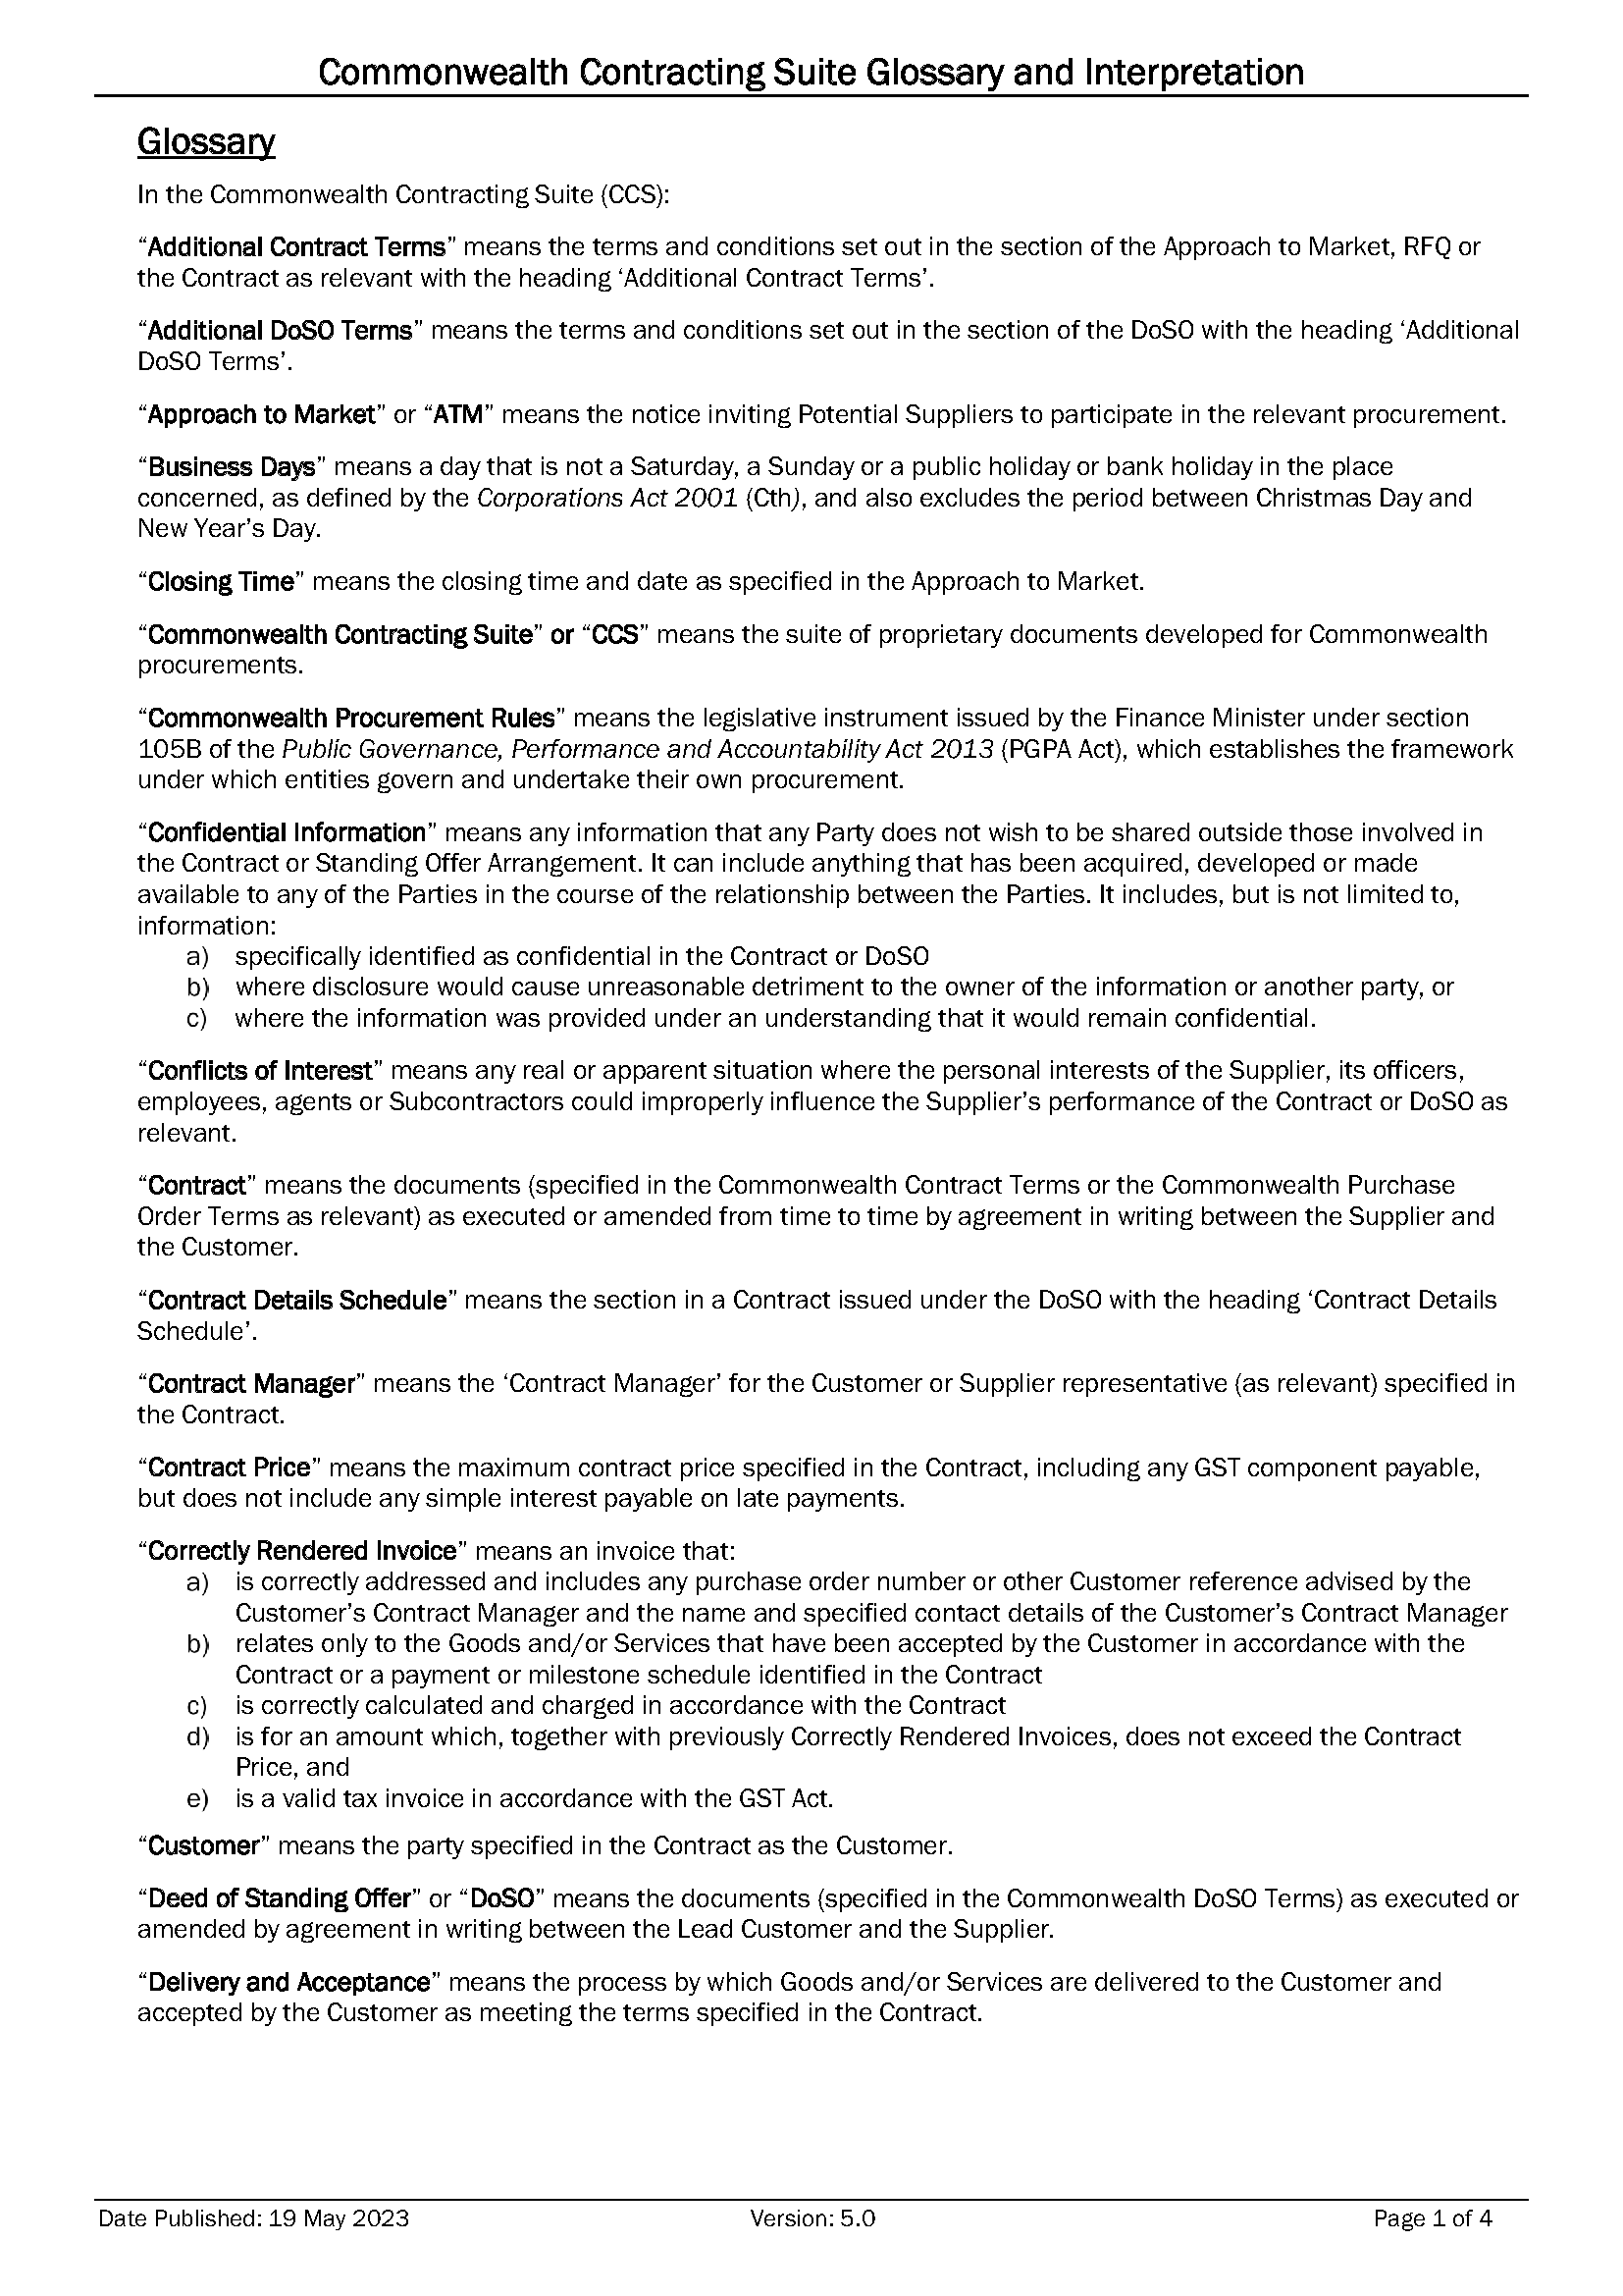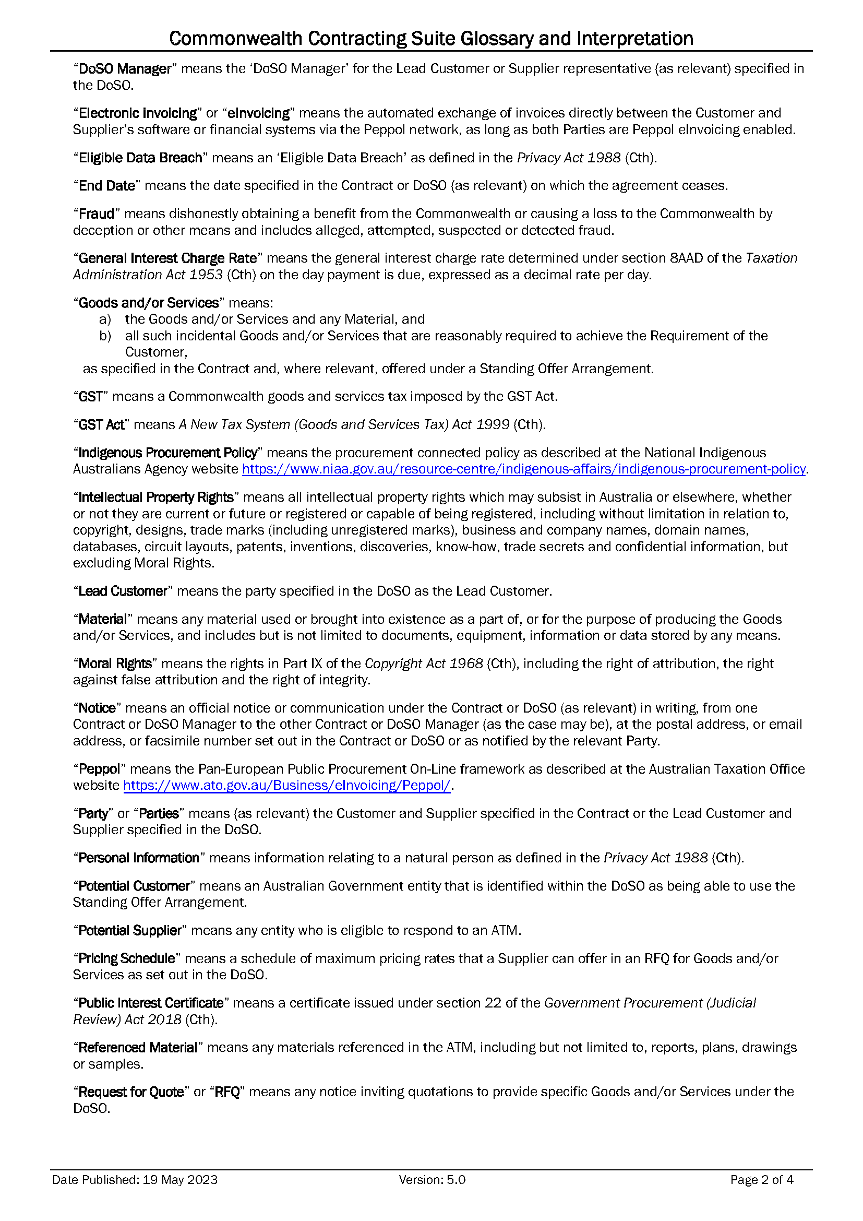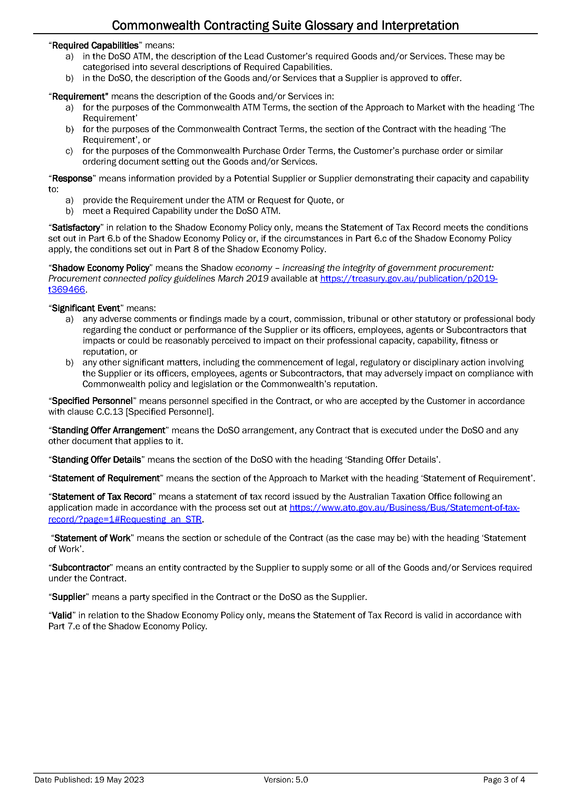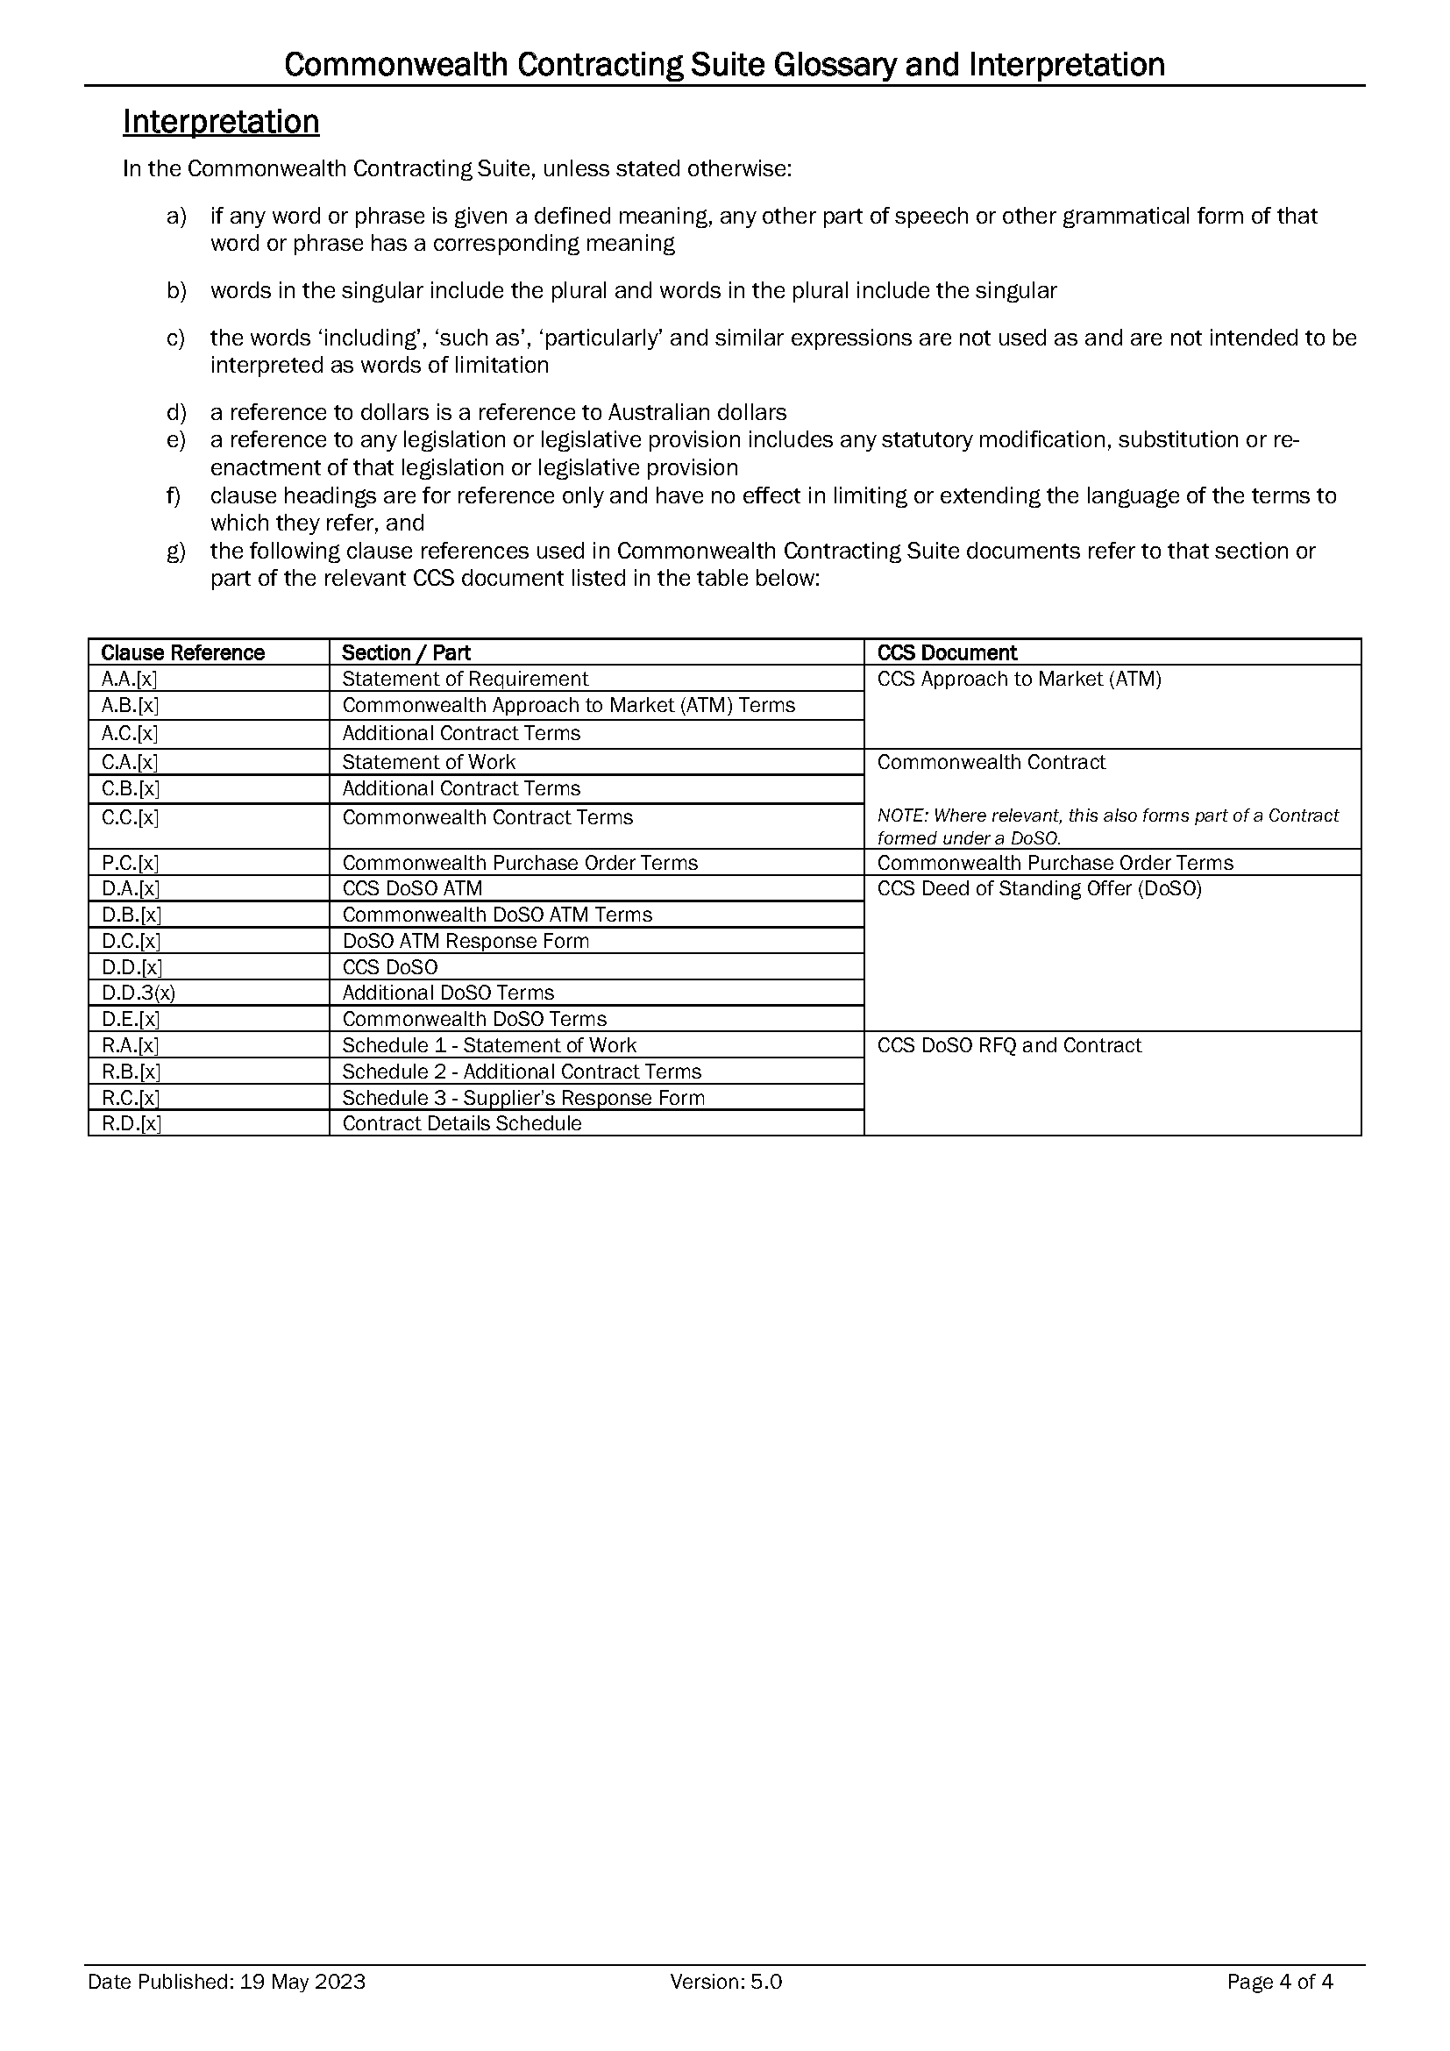
INSTRUCTIONS FOR POTENTIAL SUPPLIER
- Before you start
- This Response is not an offer for work.
- Read all the documentation provided by the Customer and distributed with this Response form and decide whether your organisation has the necessary skills and experience to meet the Customer’s requirement.
- Do not proceed further if:
  - your organisation cannot agree to the Commonwealth Contract Terms, available at https://www.finance.gov.au/government/procurement/commonwealth-contracting-suite-ccs. These terms are non-negotiable and will form part of the Contract if you are successful in this ATM process.
  - your organisation does not meet and/or agree to the Minimum Content and Format Requirements and the Conditions for Participation (if any), set out at item A.A.1 [Key Information and Dates], as failure to do so will mean your response cannot be considered.
  - your organisation is a trust where the Trustee is not empowered to sign contracts on behalf of the Trust. Before proceeding, contact the Customer’s ATM Contact Officer at item A.A.5(a) [ATM Contact Officer].
- The Customer will evaluate all valid Responses received by the ATM Closing Time [Item A.A.1] that meet the Minimum Content and Format Requirements and the Conditions for Participation (if any), to determine which Potential Supplier has proposed the best value for money outcome for the Customer. Responses will be evaluated as per the criteria set out at Clause A.B.5 [Evaluation].
- Participation in this ATM is at your organisation’s risk and cost. Please note this is a competitive process and your organisation may incur costs in responding. If you are unsuccessful, you will be unable to recoup these costs.
- Format Requirements
- You MUST use this form (CCS ATM Response Form) to submit your Response, which MUST comply with the Commonwealth ATM Terms, available at: https://www.finance.gov.au/government/procurement/commonwealth-contracting-suite-ccs.
- As this form is set out to facilitate the evaluation of responses, Potential Suppliers are to use the form as provided and are not permitted to make any changes to the structure or formatting of the document.
- Guidance for completing your Response
- Specific questions about this ATM must be directed to the ATM Contact Officer set out at Item A.A.5(a) [ATM Contact Officer] before Question Closing Date and Time set out at item A.A.1 [Key Information and Dates].
- Ensure your Response is as concise as possible while including all information that your organisation wants the evaluation team to consider. Do not include general marketing material or assume that the evaluation team has any knowledge of your organisation’s capabilities or personnel.
- Do not include pricing in any other part of your response except in the relevant Pricing Schedule.
- The successful Supplier will have demonstrated its ability to provide the best value for the Customer. This will not necessarily be the lowest price.
- Submit the form as required by Item A.A.4 [Lodgement of Responses].
- If your organisation is unsuccessful with this Response, you may request a debrief to assist with future responses. The ATM Contact Officer set out at Item A.A.5(a) [ATM Contact Officer] can arrange this for you.
Drafting Note:
Before you finalise and submit your Response, please delete all Drafting Notes, including this entire section [Instructions for Potential Suppliers].
Do not type any information within the drafting note guidance tables as any drafting notes remaining in your Response may be removed by the Customer prior to evaluation.

Response to Approach to Market
to establish
Contract for Independent Evaluation - She Leads Women's Leadership Project in Nepal
ATM Reference ID: KM23/62#4

This Response will be prepared and lodged in accordance with the Minimum Content and Format requirements as set out in A.A.1 [Key Information and Dates]. | ☐ Yes  ☐ No: Do not proceed as your Response will not be eligible for further consideration
This Response will demonstrate our ability to meet the Conditions for Participation as set out in A.A.1 [Key Information and Dates]. | ☐ Yes  ☐ No: Do not proceed as your organisation will not have the ability to fulfil the requirements of the procurement.

Potential Supplier’s Contact Officer
For all matters relating to this Response, the Potential Supplier’s Contact Officer is:
Potential Supplier Name:
Contact Name:
Position:
Telephone:
Email Address:
Postal Address:
Part 1 – Potential Supplier’s Details
Drafting Note:
The following details will appear in the Contract should your Response be successful. The details you provide should be for the legal organisation that would be the Supplier under the Contract.
1.1 Potential Supplier’s Details
Organisation’s Full Legal Name:
Legal Entity Type: | Individual/Sole Trader  Partnership  Company  Sole Director Company  Trust (see note below)  Educational Institution (see note below)  Other (please state):
NOTE FOR TRUSTS: If the Potential Supplier is trading as a trust, please provide details of the relevant trust (and trustee) including a copy of the relevant trust deed (including any variations to that deed) as an attachment to this Response.
NOTE FOR EDUCATIONAL INSTITUTIONS: If your Response is successful, prior to entering a Contract you will be required to provide details of any enabling legislation as well as details of any delegations or other authorisations that are relevant to the execution of a contract.
Australian Business Number (ABN): | Not applicable
Australian Company Number (ACN): | Not applicable
Australian Registered Body Number (ARBN): | Not applicable
Registered Address:
1.2 Previous Judicial Decisions
Has your organisation, or where relevant any of its directors, ever had a judicial decision against them (not including decisions under appeal) relating to employee entitlements or engaged in practices that have been found to be dishonest, unethical or unsafe? | Yes, see below.  No
If yes, what was the date of discharge?  The Supplier acknowledges that the giving of false or misleading information to the Commonwealth is a serious offence under section 137.1 of the schedule to the Criminal Code Act 1995 (Cth). | (DD/MM/YYYY)  Note: The Customer cannot enter a contract with a supplier who has an undischarged judicial decision relating to employee entitlements.
1.3 Workplace Gender Equality
Is your organisation classified as a ‘relevant employer’ under the Workplace Gender Equality Act 2012 (the WGE Act)? See https://www.wgea.gov.au/about | Yes, I am a relevant employer  No, I am not a relevant employer
If yes, you are required to provide a current letter of compliance with the WGE Act prior to entering into a contract. Have you provided a letter of compliance with this Response? | Yes  No, I will provide a current letter of compliance prior to contract
NOTE: If the Potential Supplier is successful in this ATM process and where the Supplier is a relevant employer under the WGE Act, the Supplier must provide evidence that it complies with its obligations under the WGE Act before commencement of any Contract and, if the term is more than 18 months, within 18 months of commencement and annually thereafter for the duration of the Contract.
If the Supplier becomes non-compliant with the WGE Act during the course of the Contract, the Supplier must notify the Customer’s Contact Manager in writing within 10 Business Days. Compliance with the WGE Act does not relieve the Supplier from its responsibilities to comply with its obligations under the Contract.
1.4 Indigenous Businesses
Is your organisation:  - 50% or more Indigenous owned?  - a joint venture that is 50% or more indigenous owned which can demonstrate equal indigenous representation and involvement in the management of the joint venture? | Yes – see question below.  No – proceed to section 1.5.
Is your organisation registered on Supply Nation? | Yes  No – see note below  Not Applicable
NOTE: Please provide a certificate or letter from a recognised Indigenous organisation such as Land Council, Indigenous Chamber of Commerce or Office of the Registrar of Indigenous Corporations verifying Indigenous ownership.
1.5 Potential Supplier’s Contract Manager
Drafting Note:
Provide details for the person you propose will be the Contact Manager if your Response is successful and your organisation is awarded a contract.

For matters relating to the proposed Contract, the Potential Supplier’s Contract Manager will be:
Name:
Position Title:
Telephone:
Mobile:
Email Address:
Postal Address:
1.6 Potential Supplier’s Address for Notices (if different from the Contract Manager)
Drafting Note:
Complete with “AS ABOVE” if same as Contact Manager.

Name:
Position Title:
Email Address:
Postal Address:

Part 2 – Executive Summary
2.1 Executive Summary of Potential Supplier’s Proposal
Drafting Note:
You may find it useful to complete this section after you have completed your response.
Provide a brief (less than one page) summary of your Response highlighting its key features. The Executive Summary should not merely replicate information provided elsewhere in your Response. This section brings together all aspects of your proposal and is your opportunity to “sell” its unique features.

2.2 Conditions for Participation
Drafting Note:
Respond to the Conditions for Participation here. Do not proceed further if you cannot meet the Conditions for Participation as your Response cannot be considered. The Customer will exclude from consideration any Response that does not meet the Conditions for Participation.
Include a statement about how your organisation meets the Conditions for Participation (if any) detailed at A.A.1 [Key Information and Dates].
If no Conditions for Participation specified, include the words: No Conditions for Participation specified.

Part 3 – Ability to Meet the Requirement
3.1 Detailed Proposal to Meet the Customer’s Requirement
Drafting Note:
Your response should address each aspect of the Statement of Requirement and explain/demonstrate how your response/solution meets the Requirement.
Provide a detailed description of your proposal to supply the Customer’s Requirement, including any delivery methodology. This is your opportunity to convince the evaluation team that your organisation understands the Requirement and can deliver it to a high standard. Do not provide general marketing material.
Highlight your competitive advantage as well as special or unique features of your proposal. Depending on the Requirement, your response may propose a detailed project plan including project milestones and completion dates, timeframes, quality standards or performance indicators. It may also detail critical issues or key delivery risks of which the Customer should be aware.
If meeting the Customer’s Requirement involves reporting, travel or attendance at meetings, you should clearly identify how you will meet these requirements, including details of personnel involved. Do not include any pricing or pricing information in Part 3. You should ensure that you clearly address any costs in your response to Part 5.

- Standards
Drafting Note:
Provide full details and evidence of compliance with all applicable Australian standards, and any Australian and international standards and requirements specified in The Requirement. Potential Suppliers are encouraged to demonstrate how any standard(s) are proposed to be specifically used in the delivery of the goods/services (i.e. provide evidence that demonstrates how your organisation complies with applicable standards in the context of the requested goods/services and attach supporting evidence as necessary).
Where you do not propose to comply with a standard which has been included in The Requirement, propose an alternative standard and justify your reasons. Where no standard has been specified, list any applicable standards with which you propose to comply.
Type “Not Applicable” below if no standards apply.

Part 4 – Potential Supplier’s Demonstrated Capability and Capacity
4.1 Statement of Skills and Experience
Drafting Note:
This section should be used to demonstrate to the evaluation team your proven capability and capacity to meet the Customer’s Requirement to a high standard and consistent quality. You should highlight your capacity and any unique capabilities that provide it with a competitive advantage.
Include your curriculum vitae in this section.
Do not include any pricing or pricing information in this Part. All pricing information should be included in Part 5.

4.2 Conflicts of Interest
Drafting Note:
Commonwealth officials have an obligation to disclose Conflicts of Interest under section 29 of the Public Governance, Performance and Accountability Act 2013 (Cth). Suppliers to Commonwealth entities need to assist the Commonwealth to meet its obligations by complying with the same standard of conduct.
Conflicts can be real or apparent. The perception of a conflict can be just as damaging to the public’s confidence in public administration as an actual conflict based on objective facts.
Provide full details of any Conflicts of Interest (if any) that could arise as a result of entering into the Contract with a Customer and propose a strategy to manage the conflict. For complex issues, you may choose to attach a Conflict of Interest Management Plan detailing your proposed approach.
After this response is submitted, Potential Suppliers must report any Conflicts of Interest that may have arisen or been identified during the evaluation period to the Customer without delay.
If no Conflicts of Interest were identified, type “Nil”.
The Potential Supplier has identified the following potential Conflicts of Interest and management strategies:
Details | Management Strategy

4.3 Referees
Drafting Note:
Provide daytime contact details for two (2) referees who can attest to your capacity to meet the Requirement. A reference is stronger if you have recently provided the referee with similar goods/services. It is good practice to ensure that nominated referees are aware they may be contacted.
Note clause A.B.5 [Evaluation]: The Customer reserves the right to contact any referees, or any other person, directly and without notifying the Potential Supplier.

Referee Name | Position | Organisation | Phone Number |  | Email Address

4.4 Pre-existing Intellectual Property of Potential Supplier
Drafting Note:
List your pre-existing Intellectual Property (if any) noting that:
The Supplier grants to, or in the case of Third-Party Material, must obtain for, the Customer a non-exclusive, irrevocable, royalty-free, perpetual, world-wide licence (including the right to sub-licence) to exercise the Intellectual Property Rights in all Pre-existing Material and Third- Party Material incorporated into the Material to enable the Customer to receive the full benefit of the Goods and/or Services and the Material and to exercise its rights in relation to the Material.
If no pre-existing Intellectual Property is proposed insert “Not Applicable”.

4.5 Confidentiality of Potential Supplier’s Information
Drafting Note:
Identify any information in your Response, or the proposed Contract, which you consider should be kept confidential, with reason(s).
The Customer will only agree to treat information as confidential in cases that meet the Commonwealth’s guidelines and which the Customer considers appropriate. If the Customer does not agree that the information meets the guidelines to be treated as confidential, the Customer has the right to disclose any information contained in the Contract.
Information to assist you to assess whether the Customer is able to treat particular information as confidential is available at: https://www.finance.gov.au/government/procurement/buying-australian-government/additional-reporting-confidentiality.
If none, type “Not Applicable”.
Add extra lines to the table as required.
The Potential Supplier has assessed that the commercial information in the table below meets the requirements available at https://www.finance.gov.au/government/procurement/buying-australian-government/additional-reporting-confidentiality and is seeking that information be kept confidential.
Information to be kept Confidential | Reasons for Confidentiality Request

4.6 Additional Information
Drafting Note:
Any information included here should be relevant to this proposal and should be as concise as possible.
The Commonwealth’s Fraud Control Framework requires the Customer to manage risk of fraud and corruption as part of contracting and procurement activities. You should include details of controls (if any) you will have in place to prevent fraud and corruption against the Commonwealth.
This section should NOT be used to include generic marketing information that is not specific to the Requirement.

Part 5 – Total Costs to be incurred by the Customer
Drafting Note:
The information you provide in this section will be used to assess the total costs the Customer will incur under your proposal.
5.1 Pricing
Fee Rates
Drafting Note:
Note: Fee rates are based on an eight-hour day.

Position Role/Level | Estimated Days | Daily Fee | Total Fee

The Customer will reimburse the Supplier for any nominated project expenses, travel, accommodation or associated expenses incurred for the purposes of the Contract. All domestic air travel is economy class and accommodation and incidental will be as per prevailing UN DSA Rates for Nepal.
5.2 Proposed Payment Schedule
Drafting Note:
Complete the table below if you propose that progress payments be made.
Do not propose a payment schedule that reflects more than the value of the milestones or deliverables you have delivered at any stage.
This payment schedule is for the Fixed Fees and Charges portion of the arrangement only. Variable costs will only be reimbursed after they have been incurred and invoiced.
Note: The Customer may propose alternative payment arrangements.
If you are not proposing any progress payments type “Not Applicable”.

Due Date | Milestone Description | Total Price  (GST Exclusive) | GST Component | Total Price  (GST Inclusive)
Total Milestone Payments

5.3 Additional Facilities and Assistance
Drafting Note:
Should you require the Customer to provide facilities and assistance, in addition to that stated at Clause A.A.2(f) [Facilities and Assistance Offered by the Customer], provide details here.
If no additional facilities or assistance required insert “Not Applicable”.
If the pricing provided above is based on the provision of Additional Facilities and Assistance this should be stated below.

5.4 Non-Compliance
Drafting Note:
If your response is successful, you will be offered a Contract which incorporates the Commonwealth Contract Terms available at https://www.finance.gov.au/government/procurement/commonwealth-contracting-suite-ccs. The Terms have been designed to enable Commonwealth officials to comply with their legislated responsibilities and are therefore NOT negotiable.
If you have reasons why any of the Additional Contract Terms should be changed, complete the following table, as these additional terms may be negotiable.
Any costs the Customer would incur in obtaining legal advice (including in-house legal advice) or negotiating the Customer’s Additional Contract Terms will be included in the Customer’s total costs assessment.

Clause | Reason for Non-Compliance | Proposed New Wording

